#include<stdio.h>

#include<conio.h>

int main()

{

float Basic,DA,HRA,Gross,Net,Tax,Final;

int ID;

char Name[25],Position[25];

printf("\n Enter the employee Name: ");

scanf("%s",Name);

printf("\n Enter the employee-ID: ");

scanf("%d",&ID);

printf("\n Enter the employee-position: ");

scanf("%s",Position);

printf("\n Enter the basic salary of the employee: ");

scanf("%f",&Basic);

DA=Basic*0.06;

HRA=Basic*0.12;

Tax=Basic*0.18;

Final=Basic-DA-HRA-Tax;

printf("\n\n\n Salary Details \n");

printf("=======================");

printf("\n Name: %s",Name);

printf("\n Employee-ID: %d",ID);

printf("\n Employee-position: %s",Position);

printf("\n Basic-salary: %.2f",Basic);

printf("\n DA: %.2f",DA);

printf("\n HRA: %.2f",HRA);

printf("\n Tax: %.2f",Tax);

printf("\n Final Salary: %.2f",Final);

getch();

return 0;

}

**Output:**

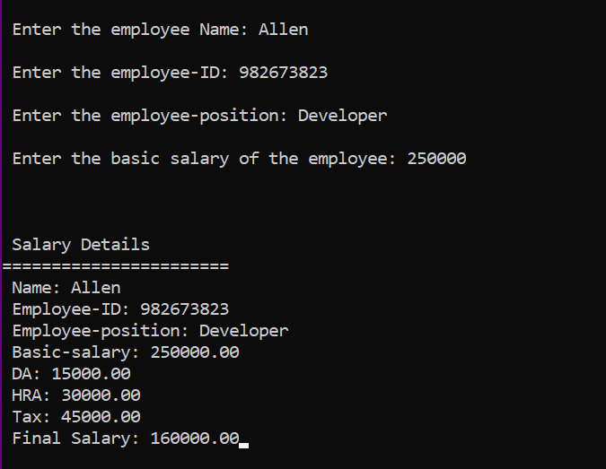

**Tokenization:**

1. Keywords: include, int, main, float, char, printf, scanf, return
2. Identifiers: Basic, DA, HRA, Gross, Net, Tax, Final, ID, Name, Position
3. Constants: 25, 0.06, 0.12, 0.18, 2, 0, \n,
4. Special Characters: (), {}, [], “”, ;, ,
5. Strings: "\n Enter the employee Name: ", "\n Enter the employee-ID: ", "\n Enter the employee-position: "
6. Operators: +, -, *